Title action research

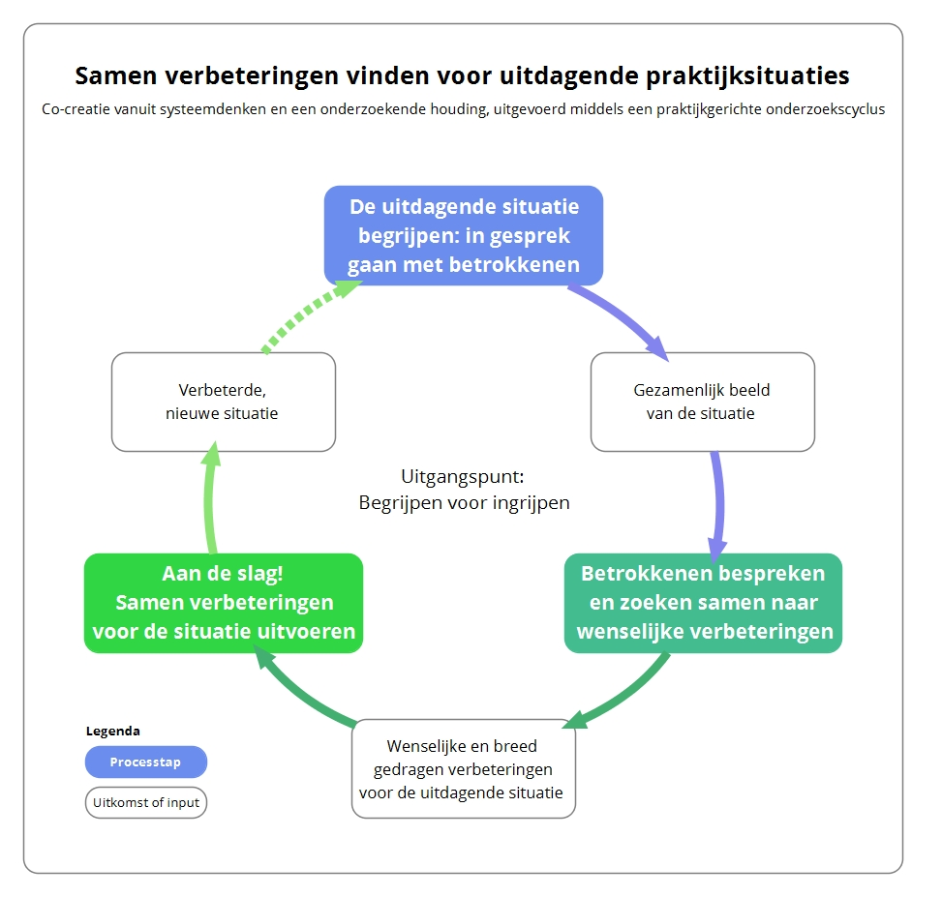

Author(s):
Place and date:

You can change the layout, structure and content of this reporting template to your own wishes and preferences of the project owner and supervisors.

Summary

Shortly describe the situation, the ambition of stakeholders, the success factors and lessons learned. Describe the research process, the outcomes, and the support you’ve found in literature (the theoretical support).

Table of content

Summary 1
Results and insights 3
Shared ambition 3
Rich picture and stakeholders’ worldviews 3
Solutions, interventions and opportunities 3
Success factors and lessons learned 3
Theoretical support 3
Reflection on the approach and the process of research 4
Phase 1: Understanding the complex and challenging situation 4
Phase 2: Stakeholders are collaboratively searching for desired solutions 4
Phase 3: Let’s get active! Implementing solutions to improve the situation 4
Reference list 5

Results and insights

Shared ambition
Describe here the shared ambition or objective of the stakeholders in this challenging situation.

Rich picture and stakeholders’ worldviews
Insert here the rich picture of the situation. Shortly elaborate on the desires and “worldviews” of the stakeholders. If needed, you can do this anonymously.

Solutions, interventions and opportunities
Discuss here the implemented or desired interventions in the situation. What is the (desired) result or effect?

Success factors and lessons learned
When is this case or challenging situation a success? What needs to be accomplished, so that the objective can be reached successfully? Discuss these success factors as specific or as smart (= measurable) as possible.

Theoretical support
Describe here the relevant results and insights from your own project or from the projects of others and from in-depth studies that are relevant for this research. Add your sources in a correct way (according to APA-criteria).

Reflection on the approach and the process of research

In this chapter you describe, as in a logbook, the three phases of systems thinking and the approach you’ve used.
Describe how you’ve experienced the interview process. What happened at the moments that stakeholders were mutually searching for jointly accepted solutions and started to work on these solutions? What was your role in this?
In other words, what were the success factors, good practices and lessons learned?

Phase 1: Understanding the complex and challenging situation
Discuss the process of conducting the interviews and how the stakeholders were starting a discussion based on the rich picture to improve their understanding of the situation. How did that process go?

Phase 2: Stakeholders are collaboratively searching for desired solutions
Describe the process during which stakeholders were searching for and exploring (possible) solutions to improve the situation. Which choices were made, and why?

Phase 3: Let’s get active! Implementing solutions to improve the situation
Discuss the implementation process, interventions taken, etc.
Or discuss how the solutions are expected to be implemented. What is needed to start working together?

Reference list

Add a list of references according to APA-criteria.

