Photogrammetry/SFM

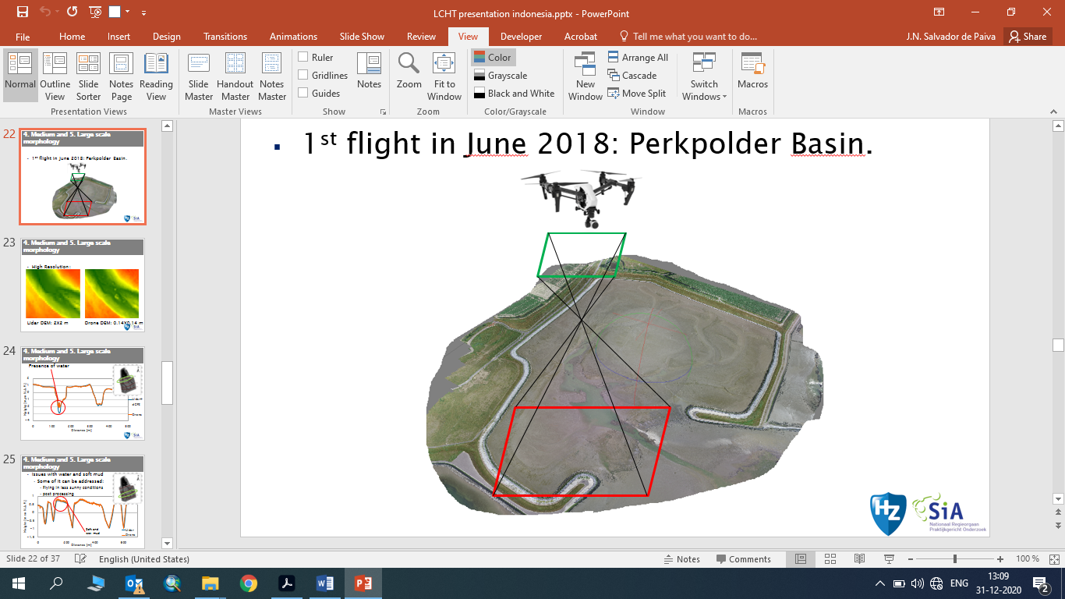

|  |  |
| --- | --- |
| **Goal** | Morphological measurements |
| **Typical area** | Tidal Flats, beaches, dunes |
| **Typical time resolution** | Weeks–decades |
| **Investment costs** | 3500 € |
| **Operation Costs** | 70€ per session ( including 0.21€/km (traveling costs) + researcher hourly rate *3.5 hours) |
| **Labor** | medium |
| **Spatial Coverage** | medium- large areas (0.1–1 km2) |
| **Time Frequency** | Interval (up to 15 per month) |
| **Detail level** | Low to medium (1-2 cm vertical resolution) |

**Method**

This method is preferably done during the low tide. The drone is deployed and pictures are taken with an overlap of at least 80% while the drone flies in passages to cover the area. The pictures are later processed using structure for motion techniques and a 3D model is generated from the 2D images.

**Materials**

* Drone
* SFM software

**Additional information**

The limitations of this method are similar to the LIDAR. Nevertheless the deployment costs are much lower. The resolution is higher but the spatial coverage is of course lower than the LIDAR.