Acoustic sensor

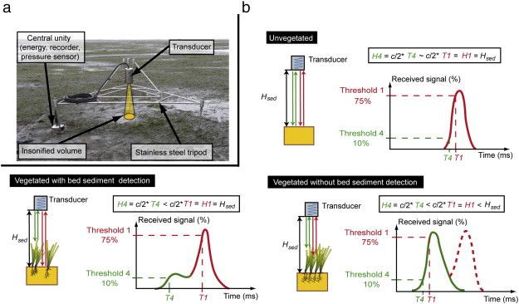

Ganthy, F., Sottolichio, A., Verney, R., 2013. Seasonal modification of tidal flat sediment dynamics by seagrass meadows of Zostera noltii (Bassin d'Arcachon, France). J. Mar. Syst. S233–S240 http://dx.doi.org/10.1016/j.jmarsys.2011.11.027 (XII International Symposium on Oceanography of the Bay of Biscay 109–110, Supplement).

|  |  |
| --- | --- |
| **Goal** | Morphological measurements |
| **Typical area** | Salt marshes, tidal flats, dunes, beaches, subtidal areas |
| **Typical time resolution** | Intra-tide–months |
| **Investment costs** | < 8000 € |
| **Operation Costs** |  |
| **Labor** | medium |
| **Spatial Coverage** | spot |
| **Time Frequency** | continuous |
| **Detail level** | high (1-2 mm vertical resolution) |

**Method**

.

**Materials**

* Acoustic sensor

**Additional information**